**6.5 Separating Similar Triangles Classwork**

1. Separate the diagram into two separate similar triangles, and orient them so that the corresponding angles and sides are in the same position in each new triangle.
2. State how you know they are similar (AA~, SSS~ or SAS~)
3. Write a similarity statement (i.e. ΔABC ~ ΔDEF)

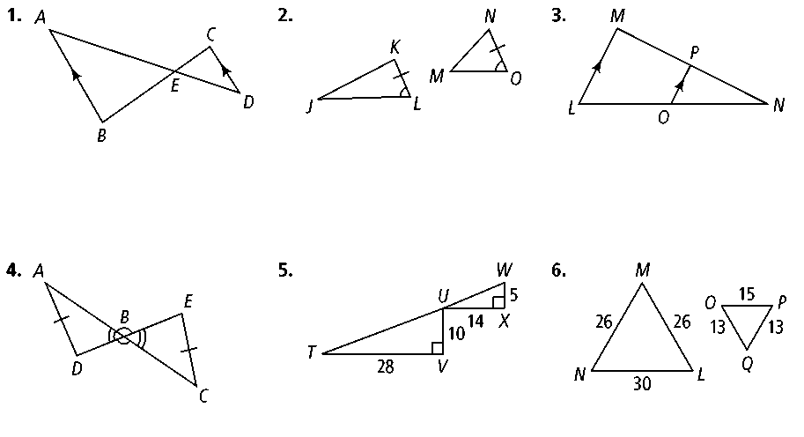**EXAMPLE:**

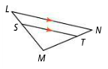

1. 
2. 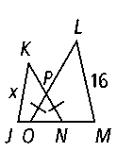

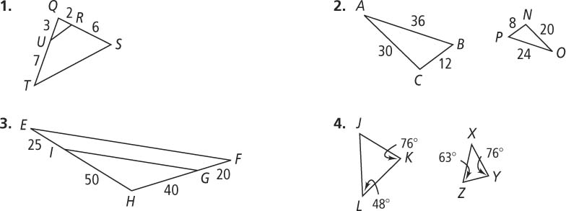



1. 

**6.5 Separating Similar Triangles HW**

1. Separate the diagram into two separate similar triangles, and orient them so that the corresponding angles and sides are in the same position in each new triangle.
2. State how you know they are similar (AA~, SSS~ or SAS~)
3. Write a similarity statement (i.e. ΔABC ~ ΔDEF)

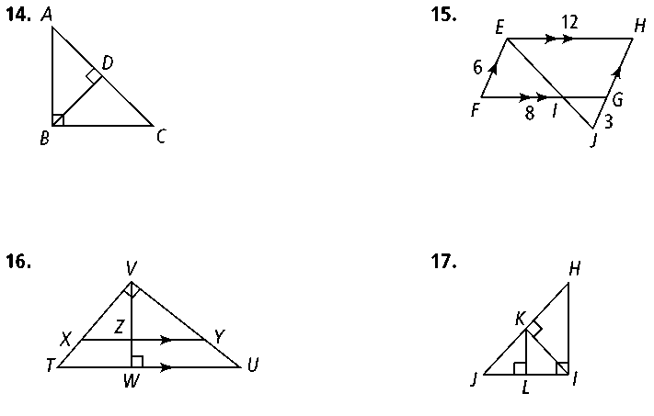**1. 2.**

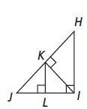**3. 4.**

**Separate the triangles in the space below:**

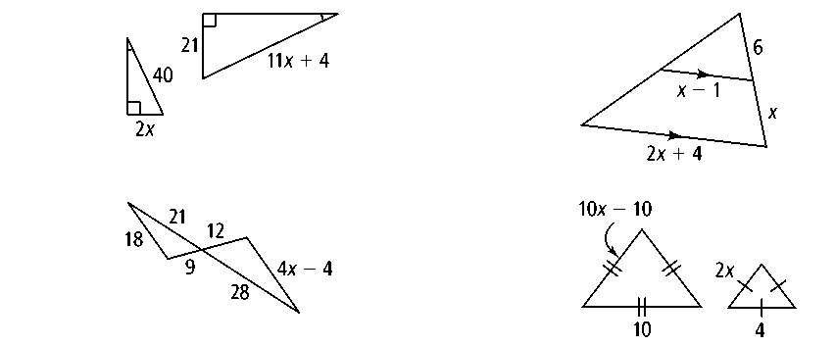

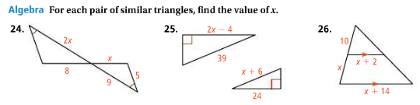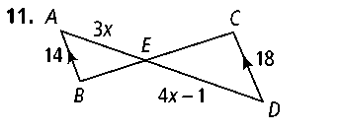**5. 6. 7.**

**Set up the proportions based on the corresponding sides of the BIG triangle and the LITTLE triangle and solve for x.**

**10.** x = _____ **11.** x = _____ **12.** x = _____

**OPTIONAL CHALLENGE PROBLEMS (up to 6 points of extra HW credit)**

